APPROVING A RESEARCH PROJECT PROPOSAL

THROUGH

pFACT
pFact (Project Financial Appraisal and Costing Tool) is the College’s system for costing and approving research grant applications.
This document illustrates how a Principal Investigator (PI) can set up an application on P-Fact, attach the relevant documentation and pass it on for approval by the College online. It does not illustrate how to do a costing on P-Fact. For this there is a more extensive documentation available entitled “pFACT Manual Applicants” which can be found at: http://www.bbk.ac.uk/rgco/researchgrants/application/pfact.shtml . It is advised that if you want to learn how to cost a project, that you should download this document and attend one of the regular research grants office training sessions on pFact. The research grants office will also continue to offer a costing service to members of staff.
In order to use P-Fact you need to be set up by the research grants office as a user. Please contact Theresa Ball at t.ball@bbk.ac.uk if you wish to be registered on pFACT. Once you have been set up as a user on P-Fact, you can create an application.

Index

1.0 Accessing pFact – p.1

1.1 Project Proposal List – p.1

1.2 Create New Project Proposal – p.2

2.0 Attaching Documents - p.4

3.0 Additional Fields (Green Card approval fields) – p.5

3.1 Change Status (first stage of approval) – p. 6

3.2 E-mail notifications on Change of Status – p. 7

4.0 Assistance – p.9

Accessing pFact, creating projects and listing them
1.0 Accessing pFACT
The ‘Live’ pFACT system is available via the Portal at http://pfact.bbk.ac.uk/Login.aspx. Copy and paste this address into your web browser, then enter your username and password. You will be given your username and password once you have attended a training session or after you have contacted the research grants office to request to be entered as a user.

As P-Fact contains sensitive financial information, it operates on a secure server. If you wish to access the system externally of Birkbeck, you need to follow the instructions at: here
Once you have logged in, you will be presented with a Data Protection Disclaimer, as salary details are accessible within pFACT.

The Data Protection disclaimer needs to be read and accepted by clicking the I Accept button. This will only appear the first time you log-in to pFACT.

1.1 Project Proposal List

After logging on, click on the Project Proposal link on the left-hand side of the menu. A list of projects to which the user has access and which have not been archived will be listed as displayed below:

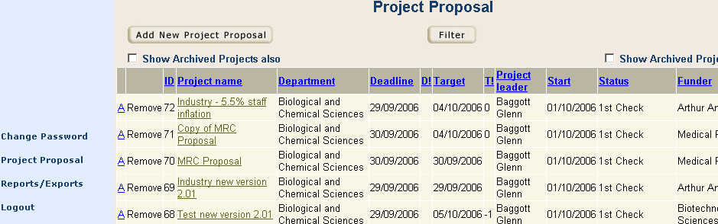

These can be sorted in any order. The default order is ID number in descending order, which ensures that latest projects appear first. All sort facilities are in ascending order except for ID as stated. The ID number is a unique number for each project, allocated chronologically by pFACT as they are set up.

To access a previous costing, click on the project name.

1.2 Create New Project Proposal

If your proposal details haven’t been set up already, then you will need to add a new project proposal.

Click on the button at the top of screen, which will display the following box to be filled in:

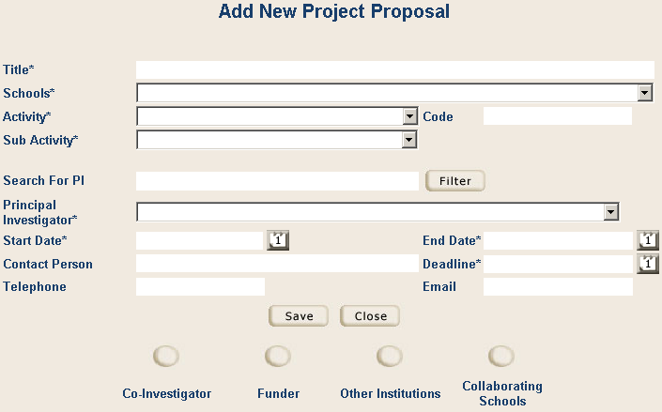

Please note that anything with a “*” is mandatory and will not allow you to progress without completing that particular field.

Firstly, type in the Title of the project.

Select the lead School for the project from the drop-down box.

The appropriate Activity to select is Research.

Sub Activity needs to be selected, based on the type of space occupied during the project – i.e. office-based, laboratory based or highly serviced laboratory based. There is also a mix of these where two types of space are used on a project. The sub activity selected determines the estates costs that the project will attract, in accordance with fEC rules.

The Principal Investigator from the lead School must be selected at this stage. The list appearing under Principal Investigator will be the entire list of staff for that School, unless the Search for PI filter facility is used. A wild-card facility is available in Search For, such that you may enter any sequence of letters. The ensuing drop-down list will contain staff that have this letter sequence anywhere within their First name or Surname. E.g. art will pull John Hart, Phil Hartley, etc.

The Start and End Dates for the project provide planned dates which may be amended later on.
Deadline is the scheme deadline or planned date of submission.

Once you have finished entering the project details, click on the Save button and then the Close button. This will bring you the Project Proposal Summary as shown below:

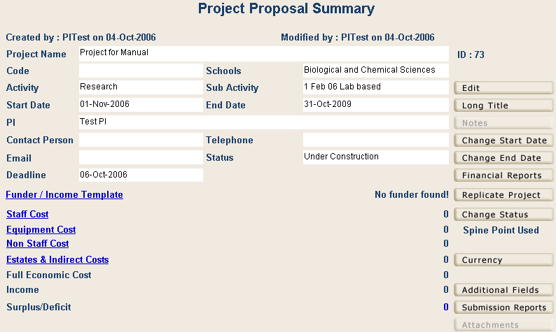

From here, you click on each of the blue hyperlinks on the left hand side of the screen to fill in the financial details of the project.

However, this usually requires prior training on how to cost a research project. Unless you are confident in using pFact for costing purposes, it is recommended that you contact the research grants office and inform them that you have set up an application on pFact (informing them of the ID number). Ensuring that you provide them with all the necessary details of your research project proposal, you can then ask them to cost the proposal for you. If they have the necessary information, the research grants office will then endeavor to enter the financial details for you. NB you must leave them at least three working days for them to do this.

Attaching Application Forms Etc. on pFact

2.0 Attaching Documents

Once you have added in the basic details of a project on P-Fact, you will need to attach a copy of your grant proposal/application and any other relevant supporting documentation necessary for this grant to be approved. NB Most grant applications are usually electronic, but if the funder will only accept a hard copy application, a copy of this should be forwarded to the research grants office.

Documents of all types (Word, Excel, pdf, jpg, etc) may be attached to a project proposal on pFact. For Research Council projects, the Description, Case for Support and Justification of Resources are the appropriate documents to attach.
Click on the Attachments button and then the button.

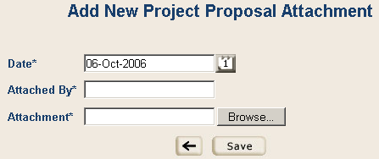

The Date defaults to the current date. The Attached By field is free text and would be your name. The attachment can be selected from any accessible location through use of the button. Once you have attached the appropriate file, click on Save and then the Back Arrow.

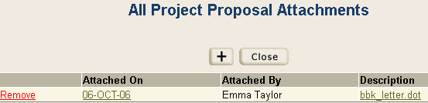

Clicking on the hyperlink Description opens the document and clicking on the link Attached On opens the record for editing initial entry details or for selecting a different document as the attachment.

Approving projects on pFact

3.0 Additional Fields (Green Card approval fields)

Once a project has been set up on pFact, correctly costed and application forms attached, the user needs to go to Additional Fields on the bottom right hand side of the main screen to approve the application. This replaces the old paper approval system of green cards

These have been set up in order to gain the necessary authorisations in place of the green card.

Click the button on the Project Proposal Summary screen which displays the following:

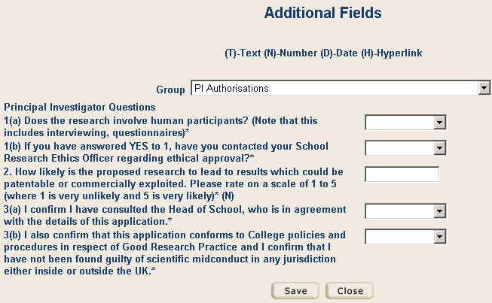

Answer each of the questions from the drop-down list and then click the Save button and then the Close button. Please note that these are mandatory questions and you will not be able to send your application for approval until these have fields have been filled out.

Workflow

As projects progress to submission they will pass through various levels of approval. At each stage in the process an email is sent to the person who is required to check the figures and sign-off. The pFACT system allows this progression to be tracked, and the status of the project can be changed to reflect this.
The different stages a project will progress through are demonstrated as follows:

Under Construction PI construction phase
RGCO Approval Research Grants has editing access
Dean Approval Dean has editing access
College Secretary College Secretary has editing access
Awaiting Final Submission Research Grants has editing access
Proposal Submitted Project is locked from editing
Proposal Unsuccessful Project is locked from editing
Funding Confirmed Project is locked from editing

Please note that once a costing is moved forward, only those at the new stage can edit the costing, although the PI and Dean can continue to view the costing and any changes made to it at every stage.

Once a project’s status reaches Proposal Submitted, no changes can be made to the proposal details by any user without first reverting the status to a level below the “freeze point”. The Research Grants & Contracts Office (RGCO) would need to be contacted in this instance.

3.1 Change Status (first stage of approval)

On clicking the Change Status button on the Project Proposal Summary screen, the Status History pops up.

To change the status, click the + button and you will be presented with the following screen:

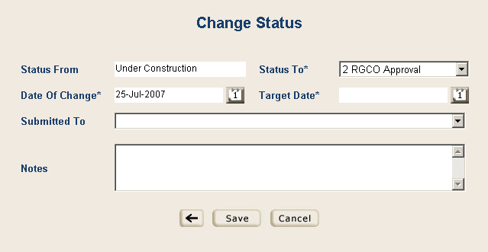

The Status To drop-down list will be restricted to level 2 – RGCO approval.

Date of Change defaults to today’s date.

Enter the Target Date, as the date by which the next stage in the process should be completed – i.e. the date which the Research Grants office should complete the first check by. Please note that each person in the process (Research Grants, Dean, College Secretary) should be given 3 full working days in which to complete their review and authorisation.

Submitted To should be left blank, as the functionality is not being used at Birkbeck.
The Notes field is pre-filled by text relevant to this change of status, determined by the System Administrator. This may be edited if required to make it more meaningful.

Press Save, which will change the status to stage 2 – RGCO approval. Please note that you must complete section 3.2 instructions in order to send an email to notify people regarding the change of status.

3.2 E-mail notifications on Change of Status

Upon clicking save, the following screen appears:

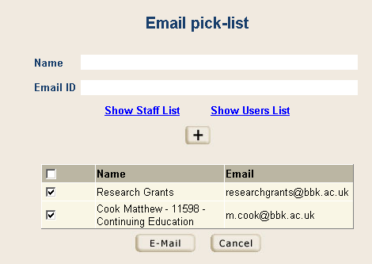

This filed informs you of who will receive an e-mail informing them that you wish your grant proposal to be approved by the Birkbeck Research Grants office. To include additional individuals who need to be informed about the change in status, there are two methods as follows:

- By clicking the blue Show Staff List hyperlink in the screen above, you would select the staff member based on Super Faculty (Birkbeck), Faculty, School, Staff. Once you have selected the correct staff member, click on the button and then which adds them to the email list.

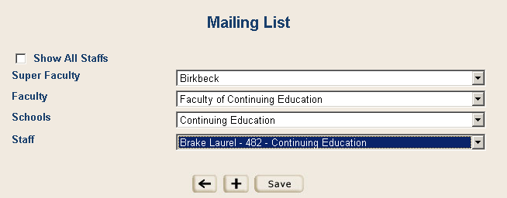

- Any other required email recipient who is not on the staff list may be added to the list simply by typing in their name and email address at the top of the screen and adding it by clicking the + button.

Once you have everyone added to the email list, click on to send.

A summary of your proposed e-mail will then appear as below:

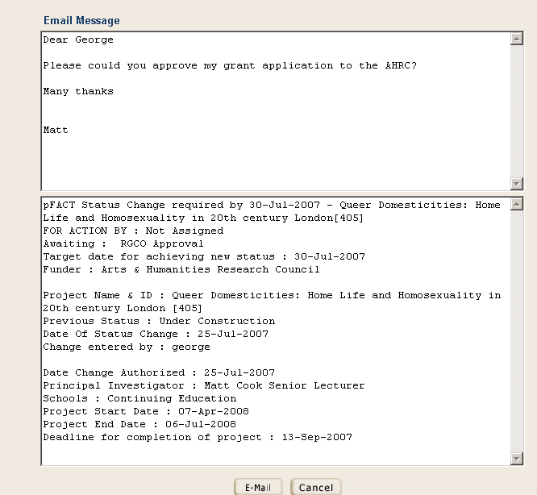

You can edit the Email Message attached to the main body of the email using the top half of screen as shown above. Once you are satisfied with the email message, click E-mail.

When a project changes status, all those who were specified as getting an e-mail, shall receive one. This list includes the named PI who is sent an email every time there is a status change and also the person who is to take the next action – in this case the Research Grants & Contracts Office.

A sample of the actual email dispatched appears as shown below. It contains all details entered in the Change Status screen.

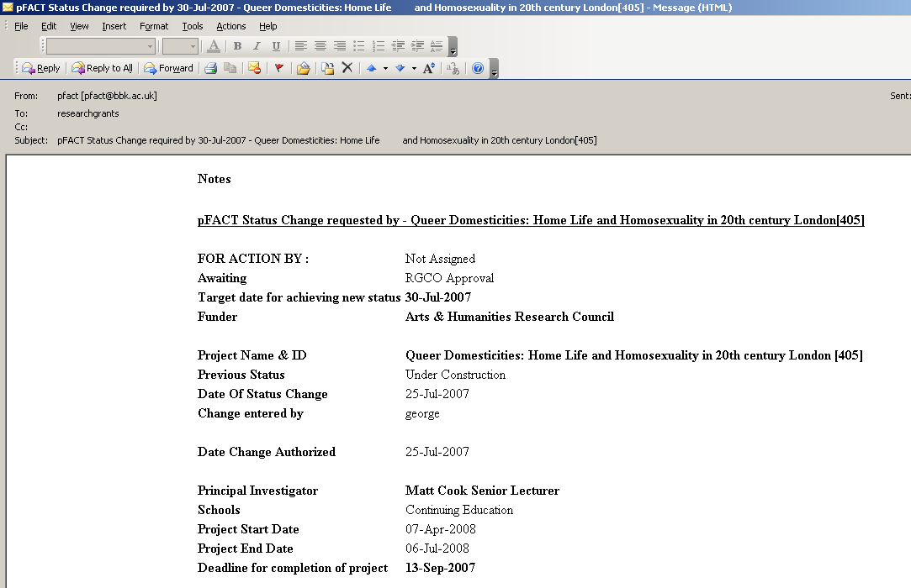

Once the PI has sent on the application, the research grants office will ensure that all other approval procedures are followed. The PI will receive an e-mail at each stage of the approval process and a final one which will declare that the Research Grants Office has submitted the PI’s application to the funder, on behalf of Birkbeck.

4.0 Assistance

Please contact:
Theresa Ball
t.ball@bbk.ac.uk
Tele: 7380 3137

If you have a query regarding the research grant itself, please contact the relevant person in the Research Grants & Contracts Office:
http://www.bbk.ac.uk/rgco/contact/index.shtml

