
Library

Creating links to journal articles in VLE (v.18a)

General tips

- Any links created need to be stable and be accessible from outside college. It is therefore not possible just to cut and paste the URL from the navigation toolbar when viewing a journal article.
- The process for creating a stable link depends on the publisher. Instructions for the main publishers are listed below.
- When inserting a link in MOODLE, don’t forget to select either Advance tab or in Target select from the drop down menu ‘Open link in new window’ otherwise this can prevent the journal article from opening.
- The easiest way of making a link accessible from outside college is to use the Library’s proxy server. Students will be directed to a log in page where they type in their IT Services username and password. There is no need to set a cookie. Occasionally some firewalls block access to this server.

Linking to journals hosted by Cambridge Journals Online

- Navigate to the content page and locate article required.
- Hover cursor on ‘PDF’ link for the required article and right click the mouse.
- Select ‘Copy Link Location’
- Paste the link into the VLE

Linking to journal articles hosted by EBSCO

- Navigate to the article required.
- Click on the article title to see the full record.
- Click on Permalink on the right hand side.
- Hover mouse over the permalink box that appears, right mouse click and select copy shortcut.
- Paste the link into the VLE.

Linking to documents in HeinOnline

- Find the document you want to link to
- Click on the icon to create a permanent hyperlink & then copy the link
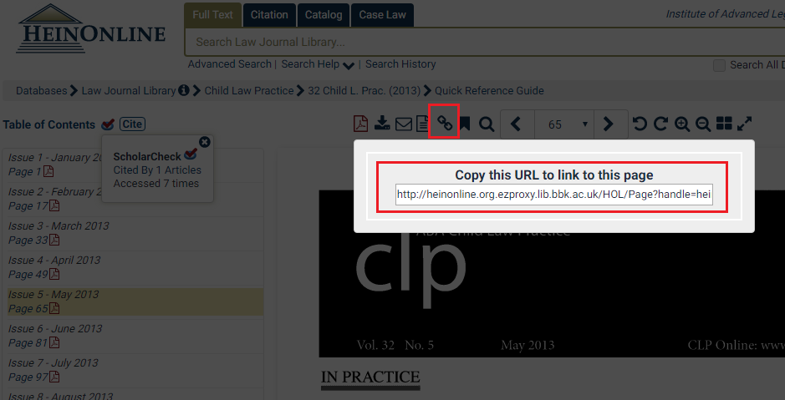

- Go to the following web site http://ezproxy.lib.bbk.ac.uk/public/proxylinkcreate.html
- Paste your link in the first box. Click the ‘Create link’ button.
- Cut the link from the second box to use in VLE.

Linking to journals hosted by Highwire Press

- Navigate to the content page and locate article required.
- Hover cursor on ‘full text PDF’ link for the required article and right click the mouse.
- Select ‘Copy Link Location’
- Paste the link into the VLE

Linking to journal articles hosted by IngentaConnect

- Navigate to the article required.
- Right click on the article title and select ‘Copy Link Location’ or ‘Copy Shortcut’.
- Paste the link into the VLE.

Linking to journal articles hosted by JSTOR

- Navigate to the content page and locate article required.
- Hover cursor on ‘Article PDF’ link for the required article and right click the mouse.
- Select ‘Copy Link Location
- Paste the link into the VLE

Linking in Lexis Library
- Login to lexis Library via the Birkbeck eLibrary
- Search for the document you wish to link to & go into the full text of the case / Act / journal article
- Scroll to the bottom of the document and click on the ‘Share link’ icon (highlighted below)
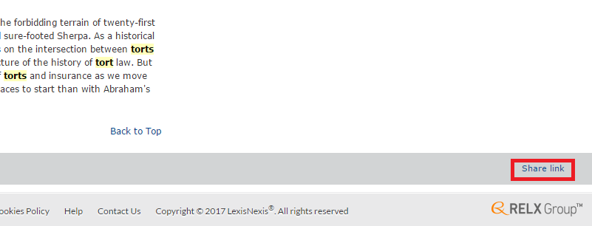
- The pop up window below will appear.
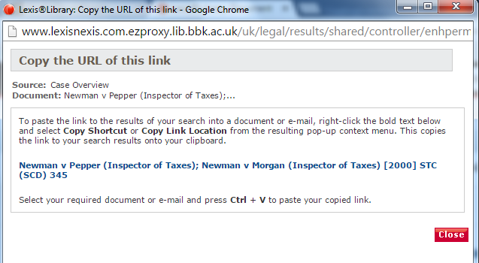

- Right click on the blue link. A popup menu will appear. Select ‘Copy Link Location’ (Firefox), ‘Copy link address’ (Chrome) or ‘Copy shortcut’ (Internet Explorer)
- Paste this link into the VLE.

Linking to journal articles hosted by MetaPress

- Navigate to the content page and locate article required.
- Hover cursor on ‘Article PDF’ link for the required article and right click the mouse.
- Select ‘Copy Link Location
- Paste the link into the VLE

Linking to journal articles hosted by Oxford Journals Archive

- Navigate to the article required.
- Hover cursor on ‘full text (PDF)’ link for the required article and right click the mouse.
- Select ‘Copy Link Location’ or ‘Copy Shortcut’.
- Paste the link into the VLE.

Linking to journal articles in PEPweb

- Navigate to the article required
- Hover cursor on the title of article, right mouse click and select ‘copy link location’ or ‘Copy Shortcut’.
- Paste the link into the VLE.

Linking to journal articles hosted by Periodicals Index/Archive Online

- Navigate to the article required.
- Hover cursor on ‘full text (PDF)’ or “Full Text” link for the required article and right click the mouse.
- Select ‘Copy Link Location’
- Paste the link into the VLE.

Linking to journal articles hosted by Project Muse

- Navigate to the content page and locate article required.
- Hover mouse over ‘Download PDF’ or ‘HTML’ link for the required article and right click the mouse.
- Select ‘Copy Link Location
- Paste the link into the VLE

Linking to journals hosted by ProQuest

- Navigate to the article required.
- Hover mouse over ‘Full text PDF’ link for the required article and right click the mouse.
- Select ‘copy link location’
- Paste the link into the VLE.

Linking to journal articles hosted by PubMed Central

- Navigate to the article required.
- Hover cursor on ‘full text’ link for the required article and right click the mouse.
- Select ‘Copy Link Location or ‘Copy Shortcut’’.
- Go to the following web site http://ezproxy.lib.bbk.ac.uk/public/proxylinkcreate.html
- Paste your link in the first box. Click the ‘Create link’ button.
- Cut the link from the second box to use in VLE.

Linking to journal articles hosted by Sage Premier/Complete A-Z

- Navigate to the article required.
- Hover cursor on ‘full text’ link for the required article and right click the mouse.
- Select ‘Copy Link Location or ‘Copy Shortcut’’
- Paste the link into the VLE

Linking to journal articles hosted by ScienceDirect (Elsevier)

- Navigate to the article required.
- Hover cursor on ‘full text’ link for the required article and right click the mouse.
- Select ‘Copy Link Location or ‘Copy Shortcut’’
- Paste the link into the VLE

Linking to journal articles hosted by SwetsWise Online Content

Please do not link to material provided via SWETS as the platform will not be available from January 2015

Linking to journal articles in Taylor & Francis
- Navigate to the article required.
- Hover cursor on ‘full text’ link for the required article and right click the mouse.
- Select ‘Copy Link Location or ‘Copy Shortcut’’
- Paste the link into the VLE

Linking to content in Westlaw

For more information about creating stable urls for Westlaw content please contact Wendy Lynwood, Subject Librarian for Law – w.lynwood@bbk.ac.uk

Linking to journal articles hosted by Wiley Blackwell

- Navigate to the content page and locate article required.
- Hover cursor on ‘full text’ link for the required article and right click the mouse.
- Select ‘Copy Link Location
- Paste the link into the VLE

