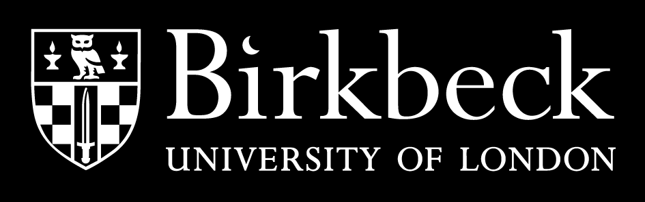
PART-TIME UNDERGRADUATE CASH BURSARY
COVER SHEET 2016/17
Student Number
Surname |  | Forename
**PLEASE TICK ALL BOXES WHICH APPLY TO YOU**
I AM CURRENTLY RECEIVING INCOME-BASED, MEANS-TESTED BENEFITS AND AM SUBMITTING:
☐ Proof of Housing Benefit/Local Housing Allowance, Universal Credit or Income Support, which is in mine or my partner’s name and dated within the last 4 weeks.
☐ Proof of Income-Based Jobseeker’s Allowance or Employment & Support Allowance, which is in mine or my partner’s name and dated within the last 4 weeks.
I RECEIVED AN INCOME IN THE 2015/16 TAX YEAR AND AM SUBMITTING:
☐ My 2015/16 P60 and can confirm that it has a tax code which does NOT end in M1, W1, BR, T or X.*
☐ My HMRC self-assessment tax return for the tax year ending April 2016 (self-employed students must submit this).
☐ My HMRC Statement of Earnings for the tax year ending April 2016 (students with multiple sources of income must submit this).
I RECEIVED NO INCOME IN THE 2015/16 TAX YEAR AND AM NOT RECEIVING BENEFITS
Please explain below how you supported yourself during this period (e.g. – reliant on parental income):
Additionally you will need to provide a letter from HMRC confirming that you had no earnings during the 2015/16 tax year. Alternatively, if you were in full-time education during the 2015/16 academic year, you can submit a letter from your previous institution confirming this.
☐ I am submitting a letter from HMRC that confirms I had no earnings in the 2015/16 tax year.
☐ I am submitting a letter which states that I was in full-time education during the 2015/16 academic year.

PLEASE NOTE THAT IF YOU ARE LIVING WITH A PARTNER YOU MUST SUBMIT ONE OF THE ABOVE DOCUMENTS AS PROOF OF THEIR INCOME, AS WELL AS YOUR OWN INCOME PROOF.
I CONFIRM I HAVE READ AND UNDERSTOOD THE INFORMATION ON PAGE 2 OF THIS COVER SHEET

I also understand that I must provide one of the types of evidence listed above, and that my document must meet the specified criteria. Failure to do so may result in my application being delayed or rejected, and I may be asked to provide further evidence in support of my application. I recognise that my application may not be considered if I do not provide the correct evidence within 28 days of enrolment, as stated on my enrolment confirmation.
Signed: |  | Date:

NO ORIGINAL DOCUMENTS REQUIRED
Please do not submit original documents as we will not be able to return them to you. If you need to make a photocopy of any documents, you may be able to do so at the My Birkbeck Student Advice Centre at our main building on Malet Street.
Partner’s Income Proof | If you are currently cohabiting, we require proof of your partner’s income, as well as your own. This proof must satisfy the same criteria as your own evidence, as detailed below. If your partner is not earning, they should still be able to request what is called a “Statement of Earnings” from HMRC for the 2015/16 tax year, which will show their earnings, if any. We can also accept a 2015/16 P60 in your partner’s name.
Parental Income | Please note that we do not accept proof of parental income, even if you are dependent upon your parents. If you were in full-time education in the 2015/16 tax year, we can accept a letter from your previous institution which confirms this. Otherwise, please see guidance on “Statement of Earnings” below.
P60/March Payslip | All assessments are made on 2015/16 income and we are therefore only able to accept evidence that covers this entire period. For this reason, we can only accept a payslip if it is from March 2016, and shows your total earnings for the 2015/16 tax year. We cannot accept a P45.
Tax Codes | Sometimes your employer or pension provider will have to use an 'emergency' or 'special basis' tax code until HMRC has worked out what your tax code should be. This can happen if you start a new job and don't have a P45, for example. If your P60 has a non-standard tax code, you will be required to request a Statement of Earnings from HMRC. Please see “Statement of Earnings” guidance below.
Statement of Earnings | If you are unable to provide evidence that complies with the specified criteria, you will need to request a Statement of Earnings from HMRC (0300 200 3300). This must show ALL sources of income from the 2015/16 tax year.
Tax Returns | Please submit your FULL 2015/16 tax return. We will only be able to accept this as proof if it shows as “submitted” to HMRC. If you have received your tax calculation for this period from HMRC, we can also accept this as proof of your income.
Means-tested Benefits | We are only able to accept the following benefits as proof of income: Housing Benefit/Local Housing Allowance, Universal Credit, Income Support, Income-based Jobseeker’s Allowance, Income-based Employment and Support Allowance. We are NOT able to accept proof of Working/Child Tax Credit, because the 2015/16 income stated on your letter is based on an estimate.
Jobseeker’s Allowance / Employment and Support Allowance | Both Job Seeker’s Allowance (JSA) and Employment and Support Allowance (ESA) can be either income based or contribution based. We can therefore only accept JSA/ESA evidence that states it is income based. Please ensure that your JSA/ESA letter clearly states this.
Evidence from outside the UK
If your income evidence is from outside the UK, we may be able to accept it provided it covers the 2015/6 tax year, or equivalent period. Please note that any documentation in a language other than English MUST be translated.
This information is for PART-TIME students ONLY

